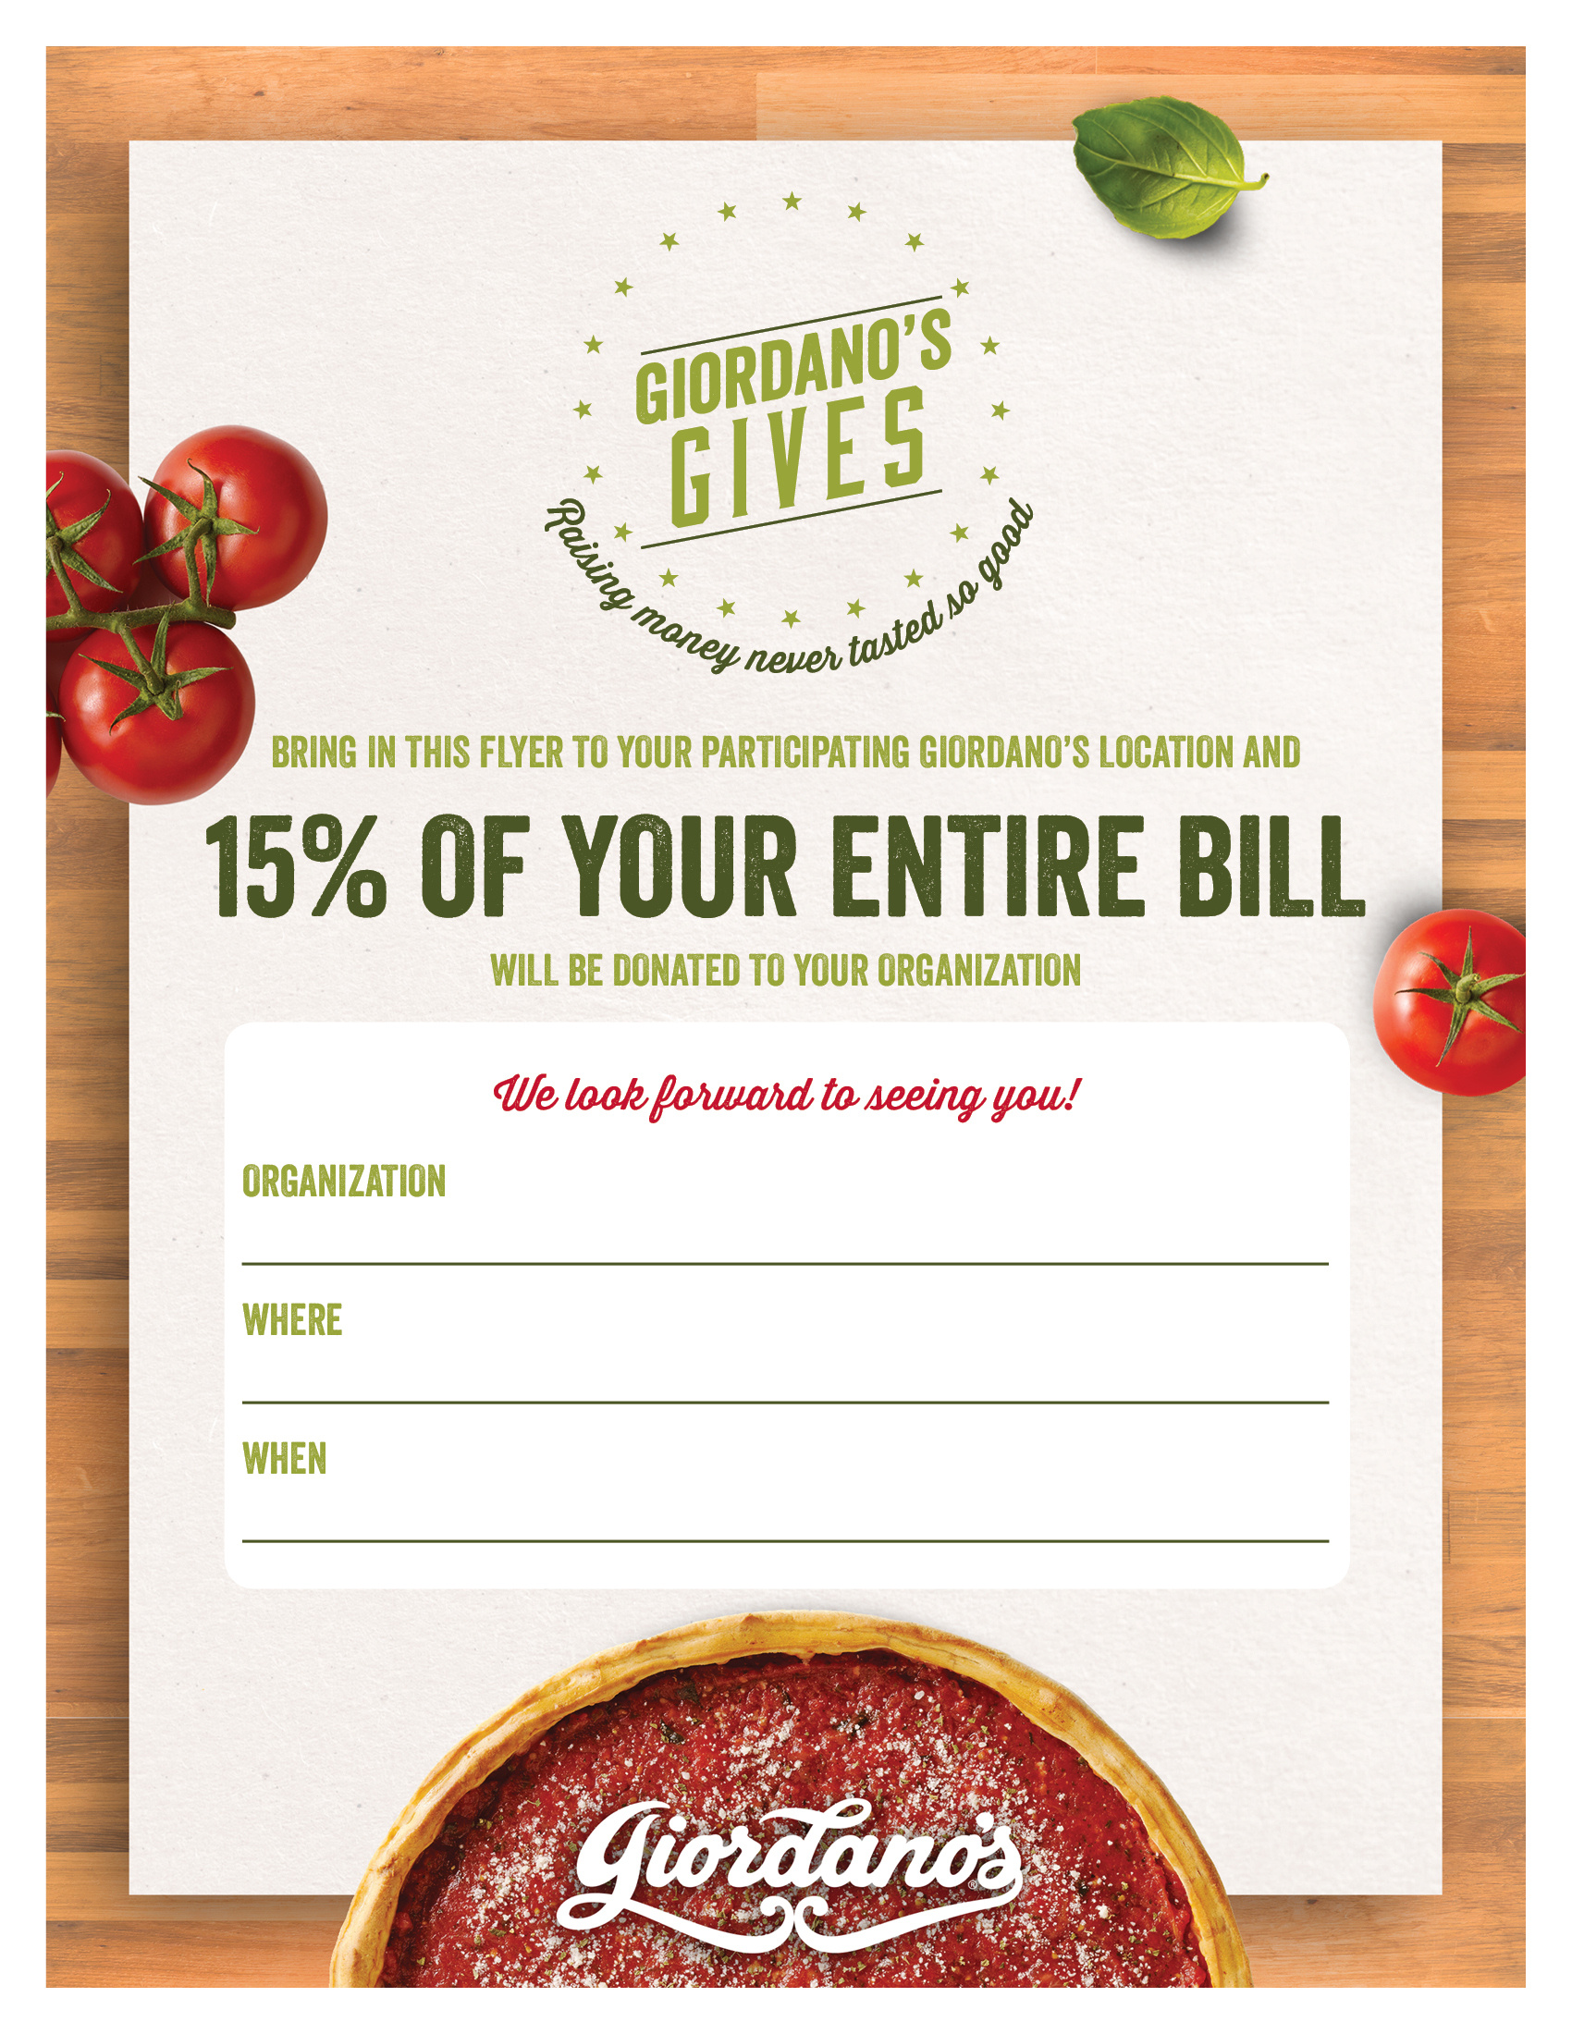

April 29th, 2017: 11:00AM – 12:00AM

Giordano’s Millennium Park: 130 E Randolph

**Be the Match Foundation**